Formula One and Bernoulli’s Principle

What is Bernoulli’s principle?

Bernoulli’s principle is the relationship between the velocity and pressure of an object inside a fluid. Bernoulli’s law state that pressure and velocity have inverse relationships, as pressure increases, velocity decrease and when pressure decreases, velocity increases.

How does Bernoulli’s principle apply to Formula 1?

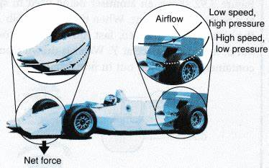

Modern Formula One cars require high downforce levels to gain time in corners. In the image above, we could see Bernoulli’s principle applied, at the top of the rear wing, there is high pressure which presses the car to the ground creating drag while at the bottom of the rear wing, pressure is lower. This is the exact opposite for airplanes.

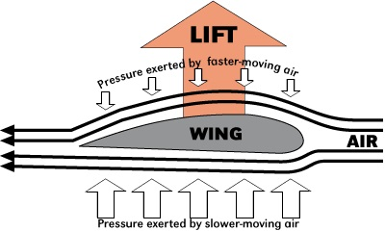The airplane requires higher pressure at the bottom to create lift while less pressure at the top with lower velocity.

The Two areas where Downforce (Bernoulli’s principle) is applied in a Formula 1 car:

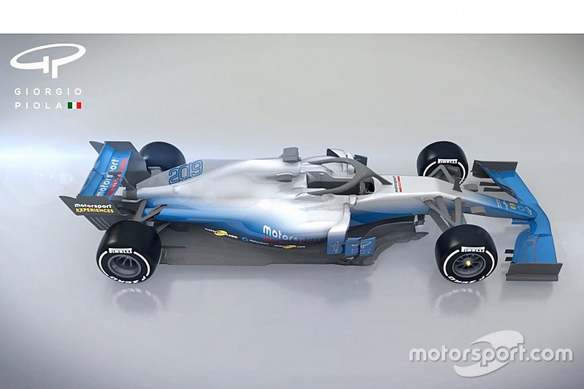

Front Wing, Rear Wing

The front wing is extremely important in producing downforce as it is the first to encounter undisturbed airflow. The front wing redirects airflow to the rest of the car such as the diffusors, bargeboards, engine intake, floor and the rear wing. One example would be the front wing trying to redirect harmful turbulent air from the uncovered wheels of the car.

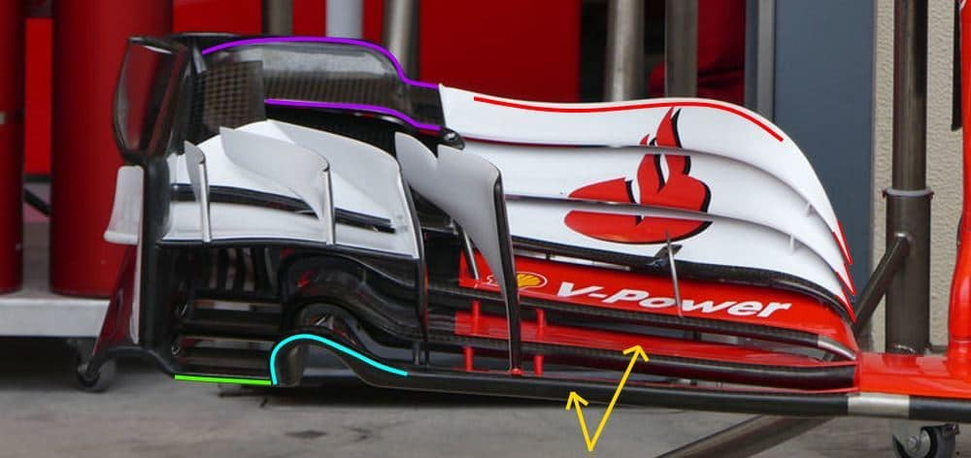The front wing of the car is shaped similarly to the rear wing of the car with high pressure at the top of the front wing to press the wheel axles downward

My CFD (Computational Fluid Dynamics) test on a Formula 1 model from 2017

Pressure and Velocity relationships on f1 2017 model:

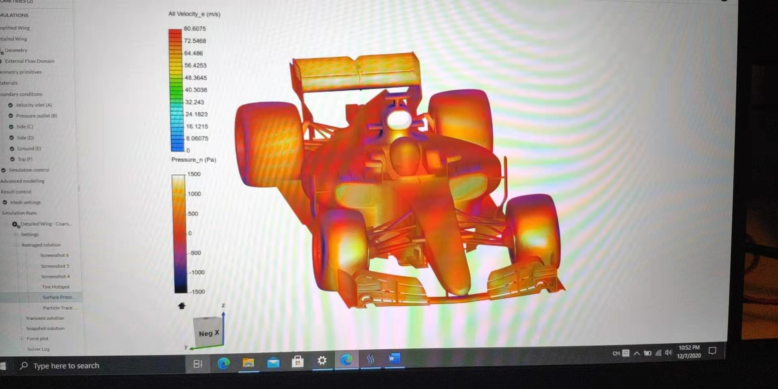

Areas with high pressure such as the front and rear wing 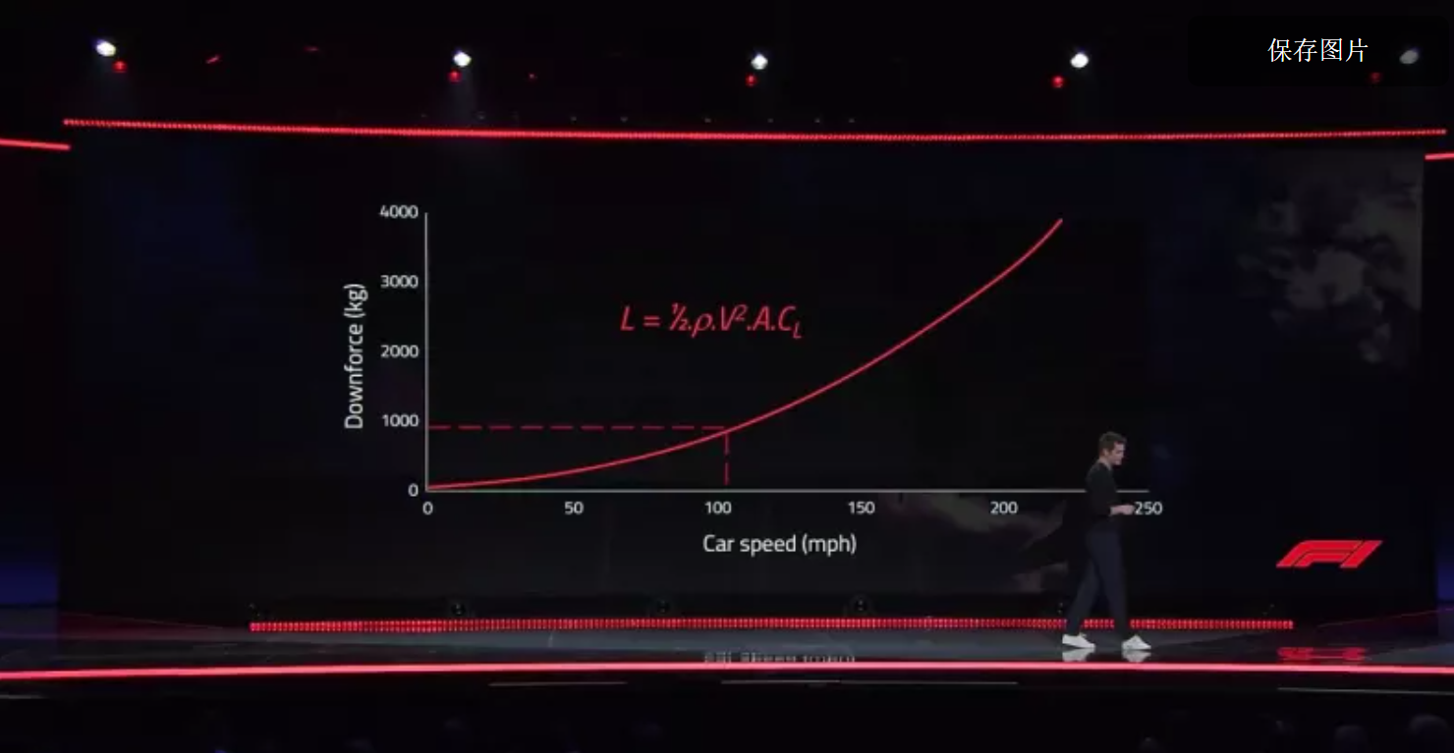

(Lift formula could also be applied to calculate the downforce produced by the car)

* **L** = Lift, which must equal the airplane's weight in pounds
* **d** = density of the air. This will change due to altitude. These values can be found in a I.C.A.O. Standard Atmosphere Table.
* **v** = velocity of an aircraft expressed in feet per second
* **s** = the wing area of an aircraft in square feet
* **CL** = Coefficient of lift , which is determined by the type of airfoil and angle of attack.

Modern formula 1 cars can produce 4 tons of downforce when reaching velocity of 402.5km/hr

322km/hr can produce 3 tons of downforce

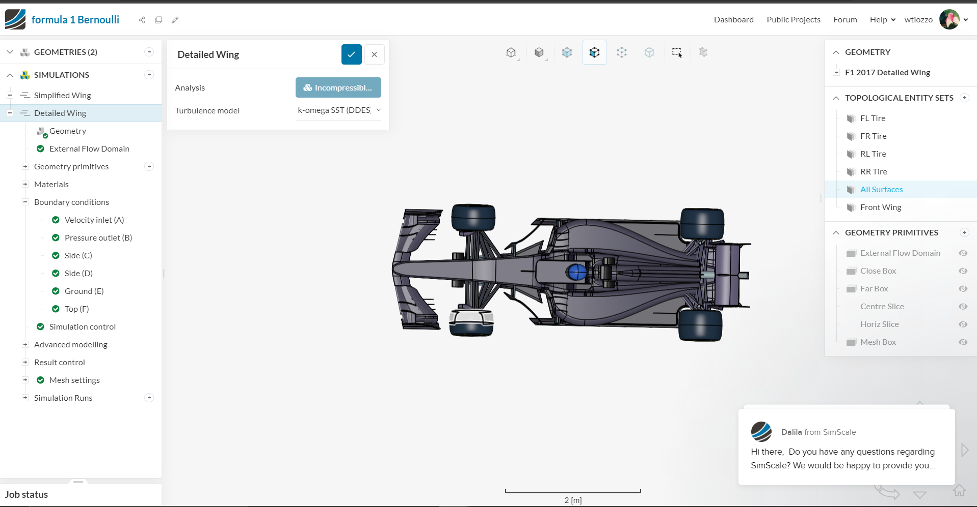

Wind tunnel testing for F1 2021 cars, spoilers decrease on the f1 front wings. Decrease in downforce and a significant lift in the rear wing to create better slipstream effects (When two cars follow each other, the car ahead creates a huge gap in the air at the end on the rear wing. The gap is sort of like a vacuum which allows the second car to increase its velocity dramatically due to a significant decrease in air resistance. This could cause the car behind to lose more than 50% of its original downforce.) 2021 cars are designed to solve this issue with less dirty air produced by the car ahead.

